**About CLTS**

CORPORATE LINK TECHNICAL SERVICES L.L.C. is an electrical contracting company established in From 2016 till date, has honed its operational and technical expertise to emerge as a formidable name in the industry of construction and post building services, providing specialized design and execution solutions, fabrication through to turnkey installations in the industrial and electrical engineering sectors. We are a proud participant in the generation of employment opportunities and thereby contributing to the fast developing Gulf economy.

Today, with a team of experienced professionals from many global communities, is perhaps one of the most diverse engineering and electro-mechanical contracting service providers in the true sense of the word. Our quest is to achieve our vision for the future through our association with prominent clients and we are quite certain that , with its sound foundations, highly motivated management and dedicated personnel will help us satisfy our appetite for excellence.

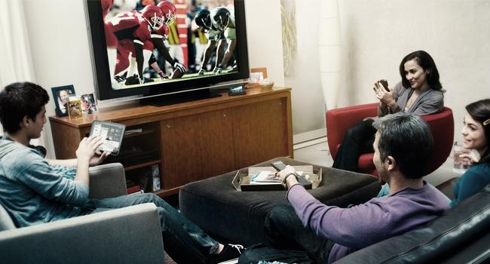

Projects:

* Completed Projects:

Townsquare Development – Dubai

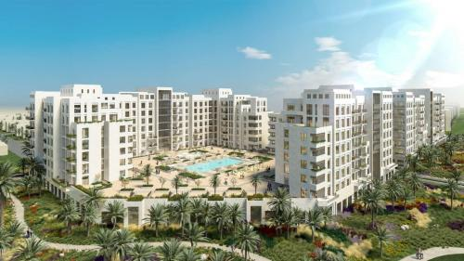

PROJECT NAME

- Townsquare Development, phase 1: Hayat Boulevard, Al Qudra Rd, Dubai

CLIENT

- Nshmi Development LLC

MAIN CONTRACTOR

* UNEC

CONSULTANT

* Studio International Engineering Consultant Ongoing projects

MEP contractor

* Al-Mohanad Electro-Mechanical contracting company.

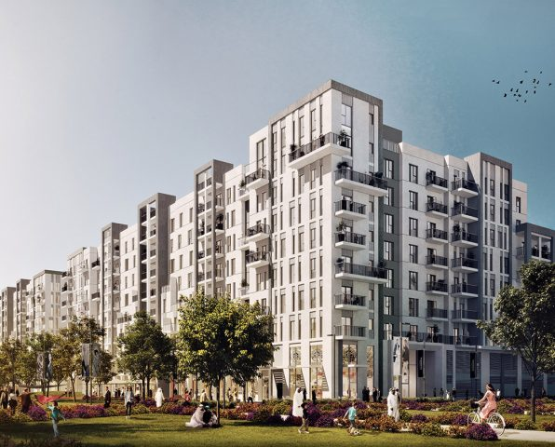

TownSqaure Development, Phase I: Zahra Breeze Apartments, Al Qudra, Dubai

PROJECT NAME

* Townsquare Dev't, phase 1: Zahra Breeze Apartments, Al Qudra, Dubai

CLIENT

* NSHMI Development LLC

MAIN CONTRACTOR

* UNEC

CONSULTANT

* Studio International Engineering Consultants

MEP contractor

* Al Mohamad Electro-Mechanical Contracting Company

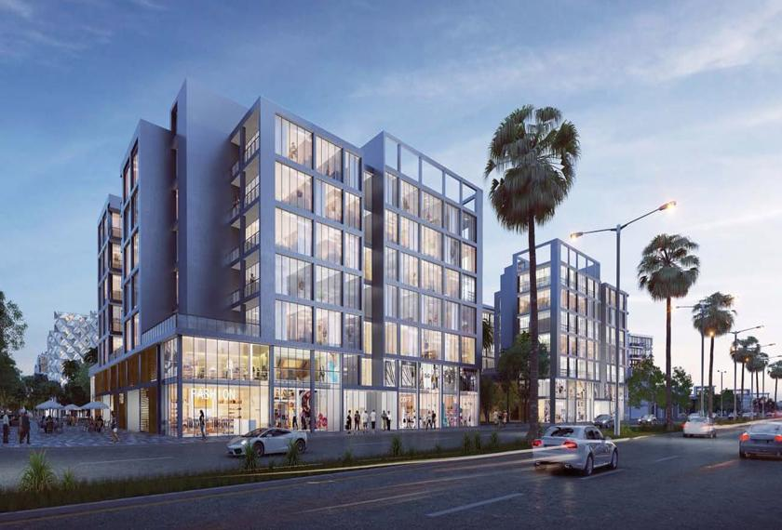

ARADA AL AREEJ 5,6,7

PROJECT NAME

* AL AREEJ 5,6,7 (B+G+6) BLDG. -AL JADA DEV'T, BLOCK L, SHARJAH

CLIENT

* ARADA DEVELOPMENTS LLC

MAIN CONTRACTOR

* MODERN BUILDING CONTRACTING CO.

CONSULTANT

* ARIF & BINTOAK Consulting Architects & Engineers

MEP contractor

* Al Mohanad Electro-Mechanical Contracting Company

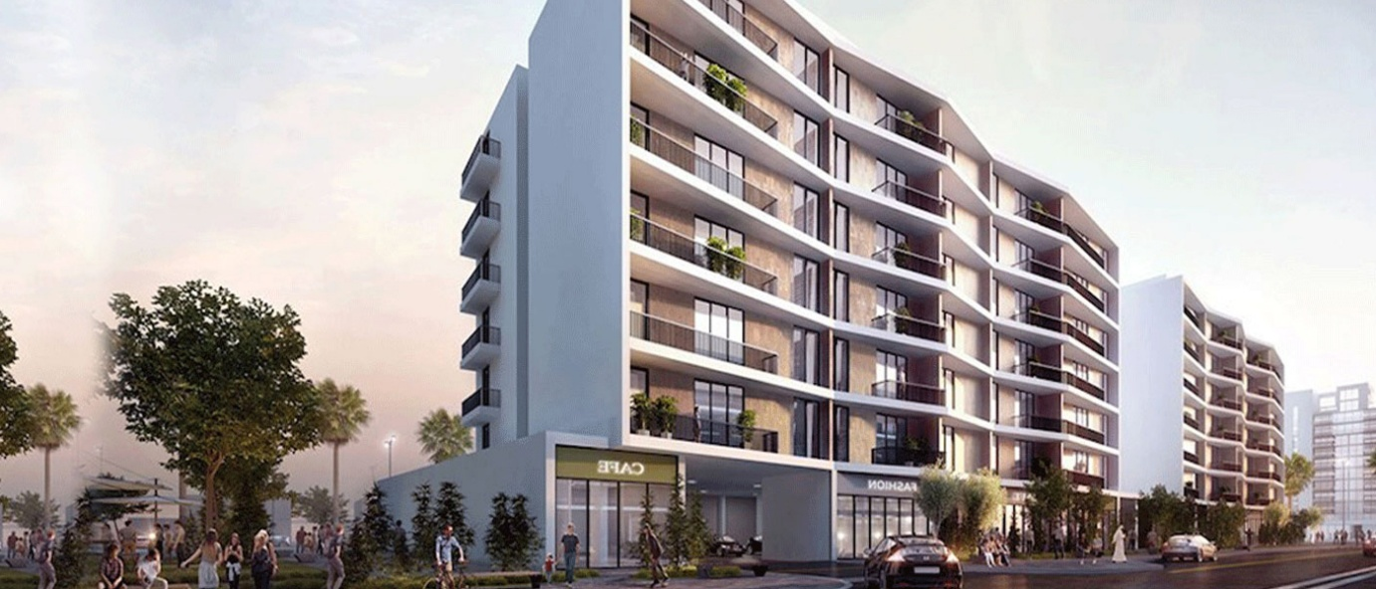

ARADA Al Rehan 1,2,3

PROJECT NAME

* AL REHAN 1,2,3 (B+G+6) BLDG. -AL JADA DEV'T, BLOCK L, SHARJAH

CLIENT

* ARADA Developments LLC

MAIN CONTRACTOR

* Intermass Engineering & Contracting

CONSULTANT

* ARIF & BINTOAK Consulting Architects & Engineers

MEP contractor

* MEMCO

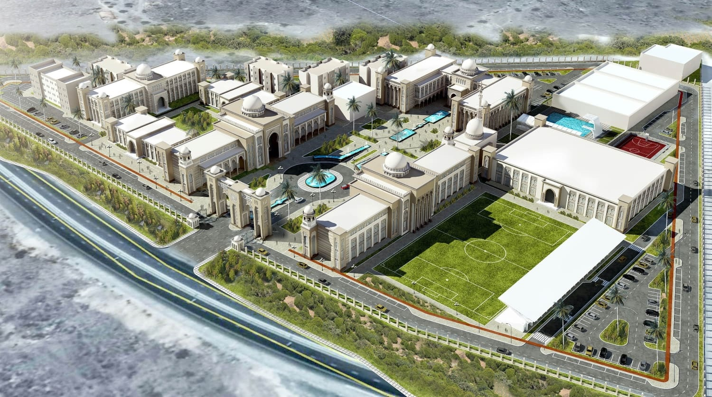

Arab Marine Academy

PROJECT NAME

* Arab Marine Academy for Science Technology & Maritime Transport at Al Khorfakkan Br.

CLIENT

* Government of Sharjah

MAIN CONTRACTOR

* UNEC

CONSULTANT

* QHC Architects & Engineers

MEP contractor

* MEMCO

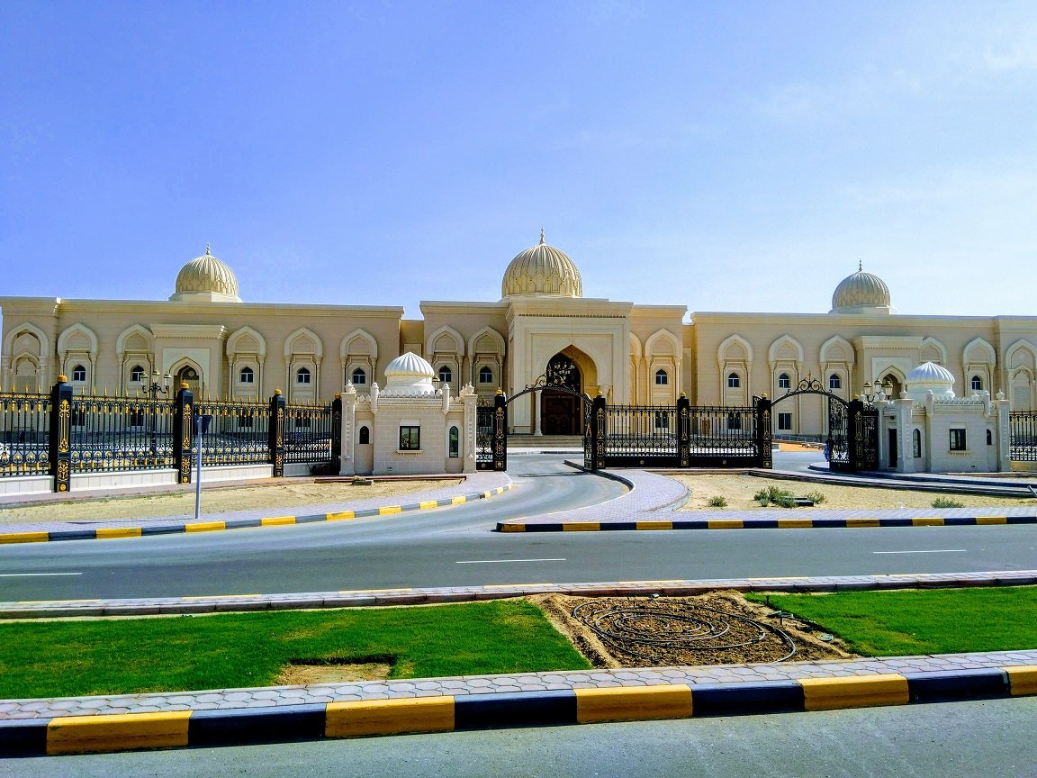

Sharjah Academy of Performing Arts

PROJECT NAME

* Construction of Sharjah Academy of Performing Arts, Sharjah

CLIENT

* Govt. Of Sharjah

MAIN CONTRACTOR

* Darwish Engineering Emirates

CONSULTANT

* C.A.B Consultant

MEP contractor

* MEMCO

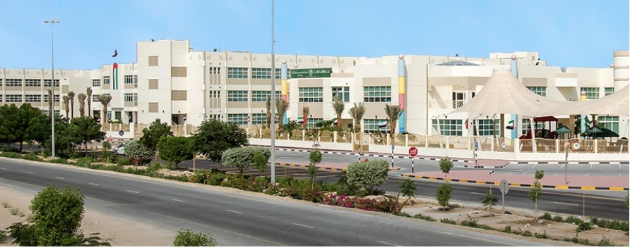

The International School Of Choueifat Dubai

PROJECT NAME

* The International School of Choueifat

CLIENT

* SABIS

MAIN CONTRACTOR

* Darwish Engineering Emirates

CONSULTANT

* Arab & Turk International

MEP contractor

* MEMCO
* ONGOING PROJECTS:

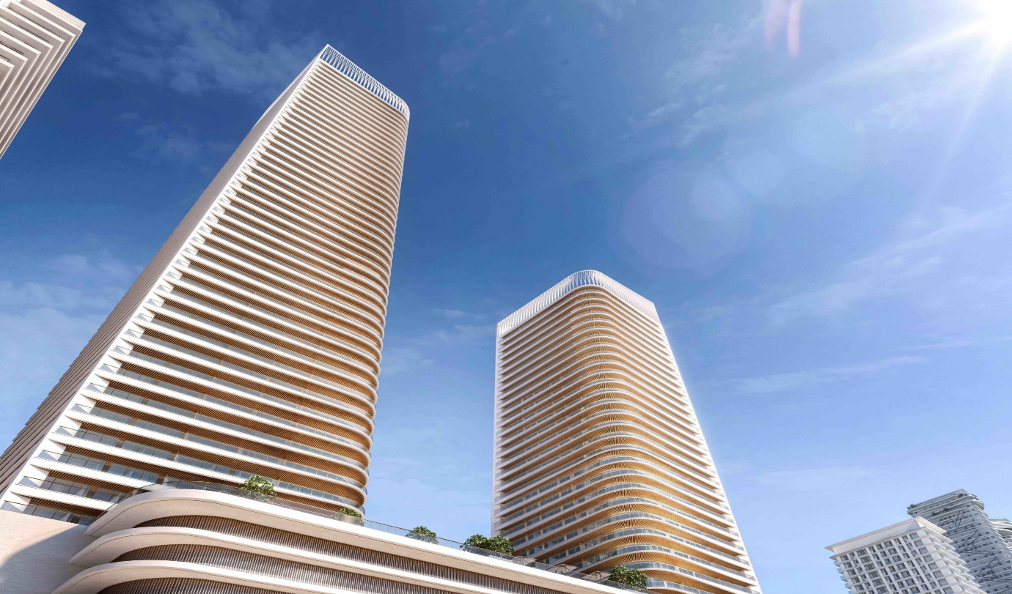

GRAND BLEU TOWER

SCOPE OF WORK:

PROJECT : GRAND BLEU TOWER (B-G-45-RF) & (B-G-26-RF)

LOCATION : PARCEL ID - SH1.Z02.B07, MARSA DUBAI, UAE

CLIENT : EMAAR PROPERTIES PJSC

CONSULTANT : MIRAGE LEISURE AND DEVELOPMENT LLC

MAIN CONTRACTOR : ENGINEERING CONTRACTING COMPANY LLC

MEP CONTRACTOR: AL ARABIA SAFTY AND SECURITY.

**GALLERY:**

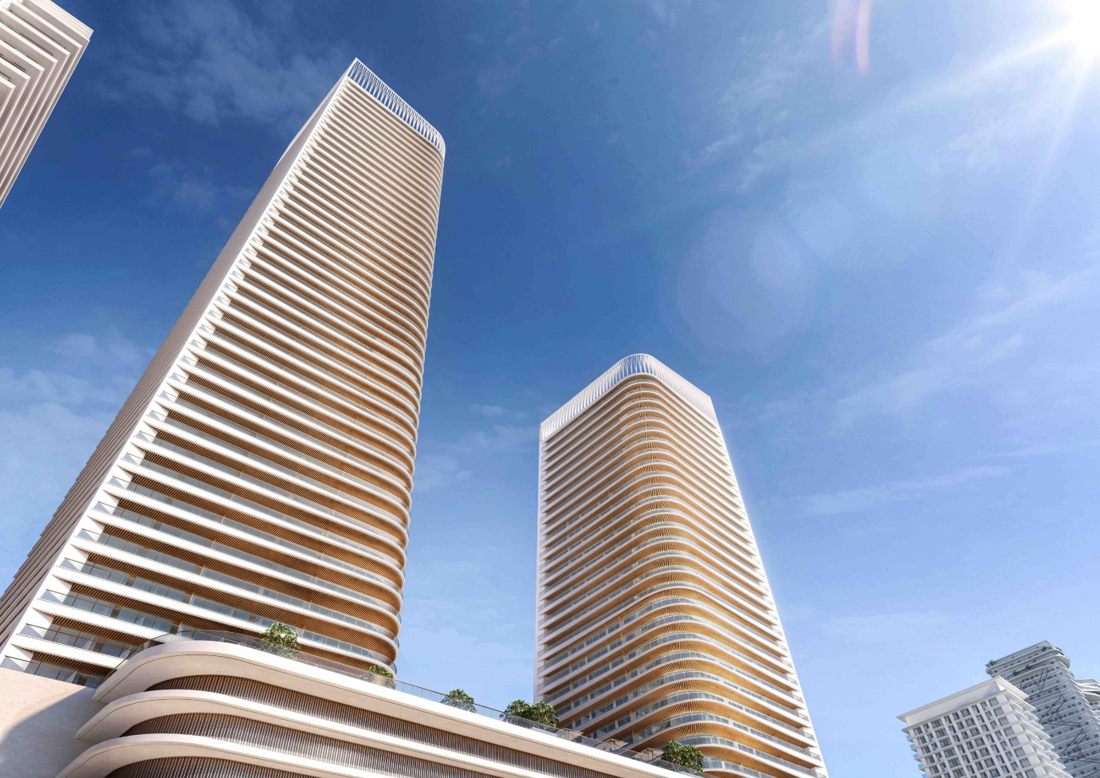

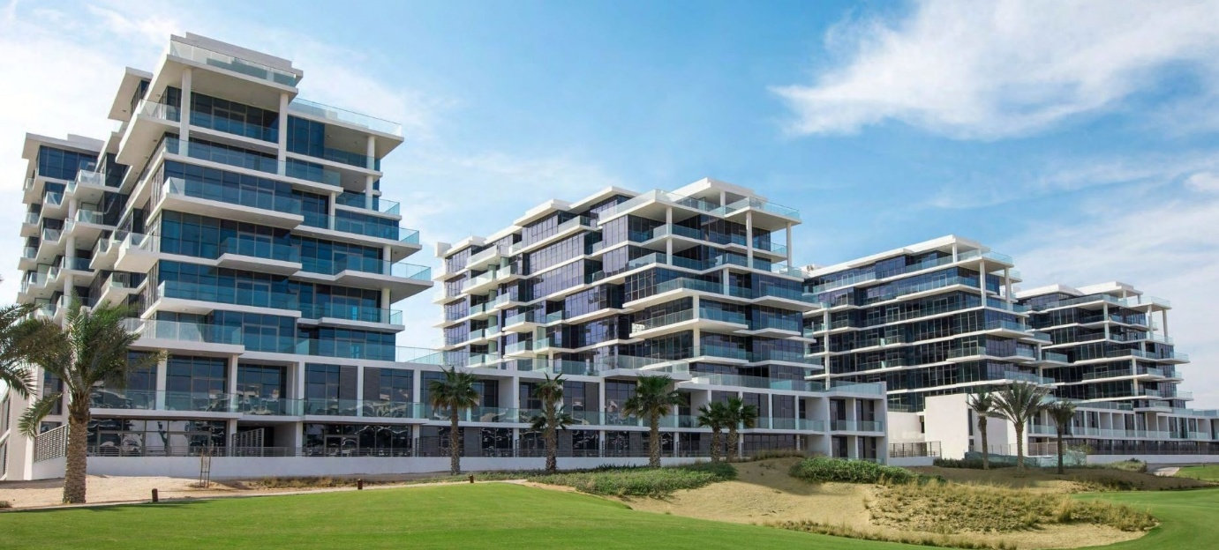

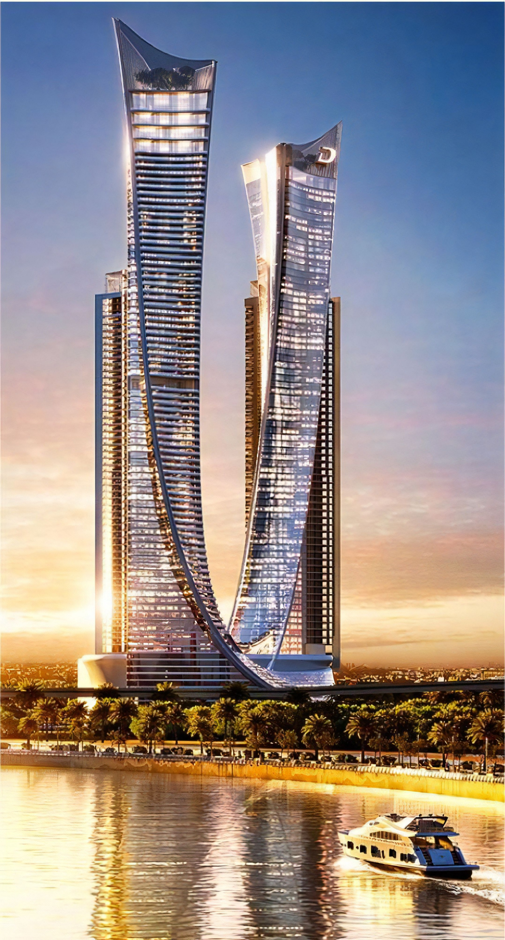

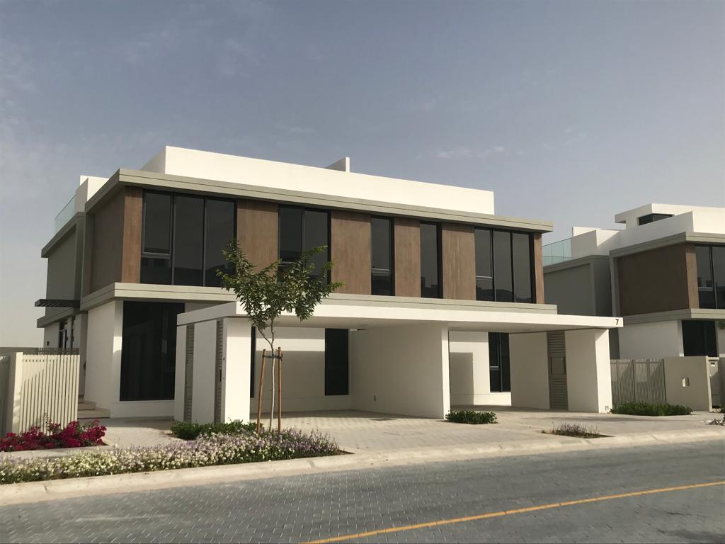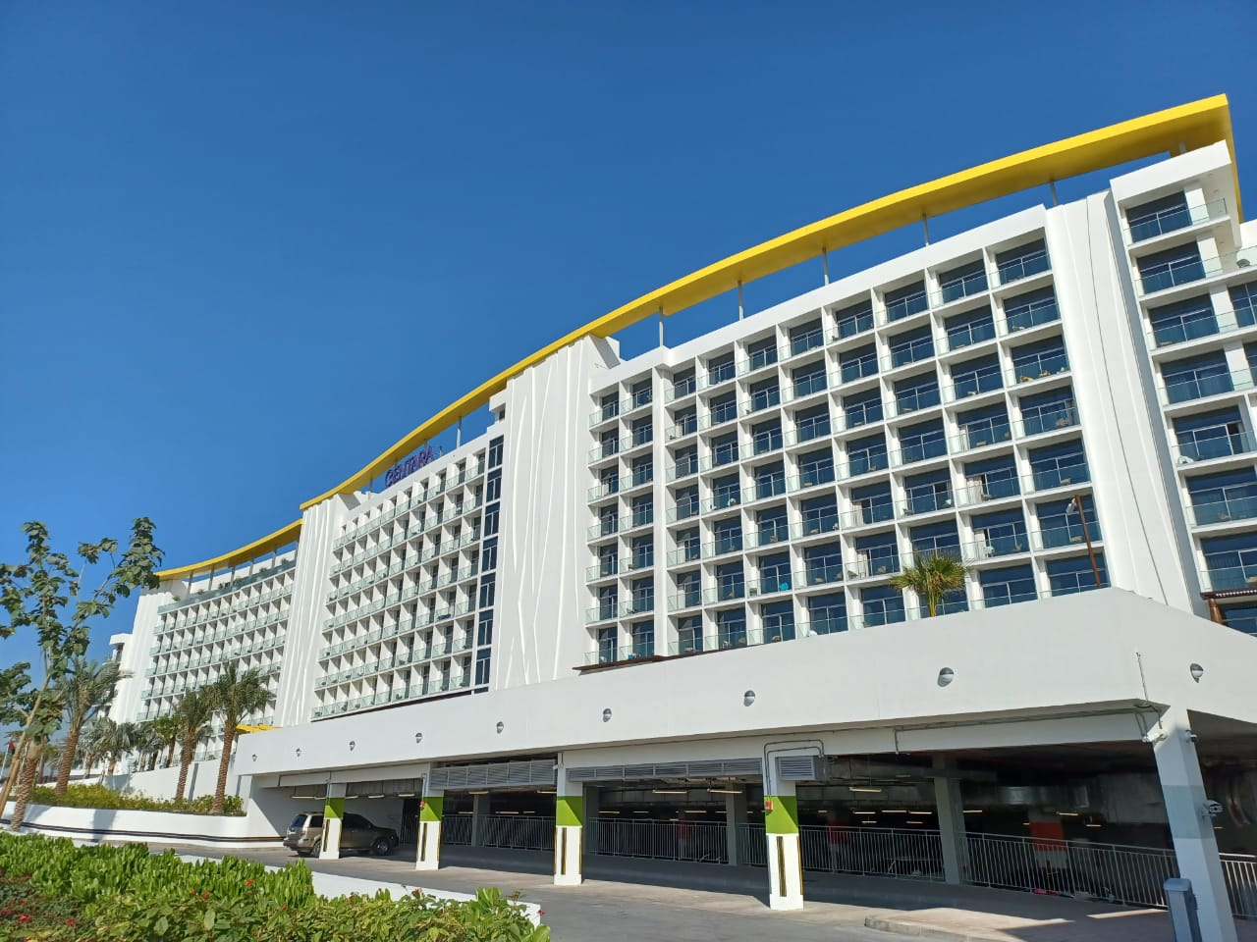

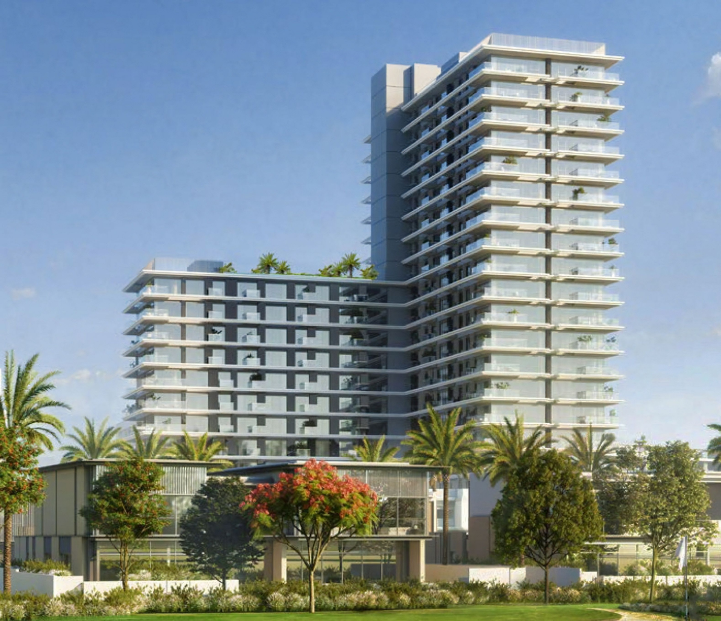

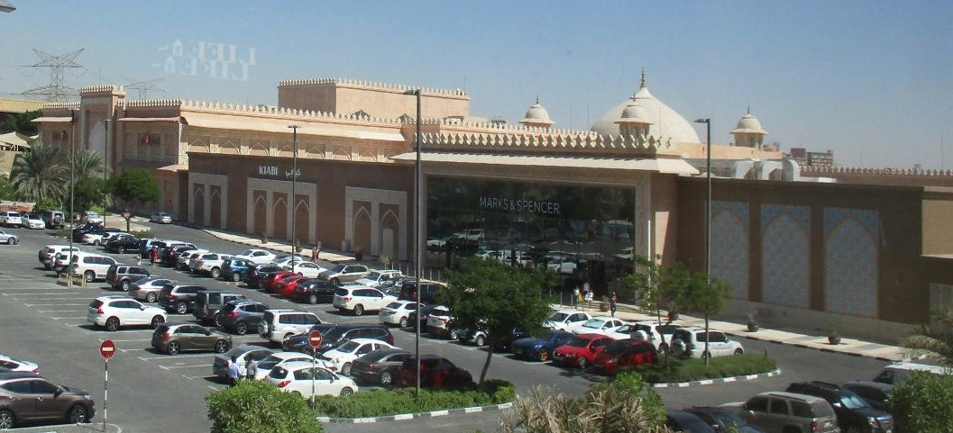

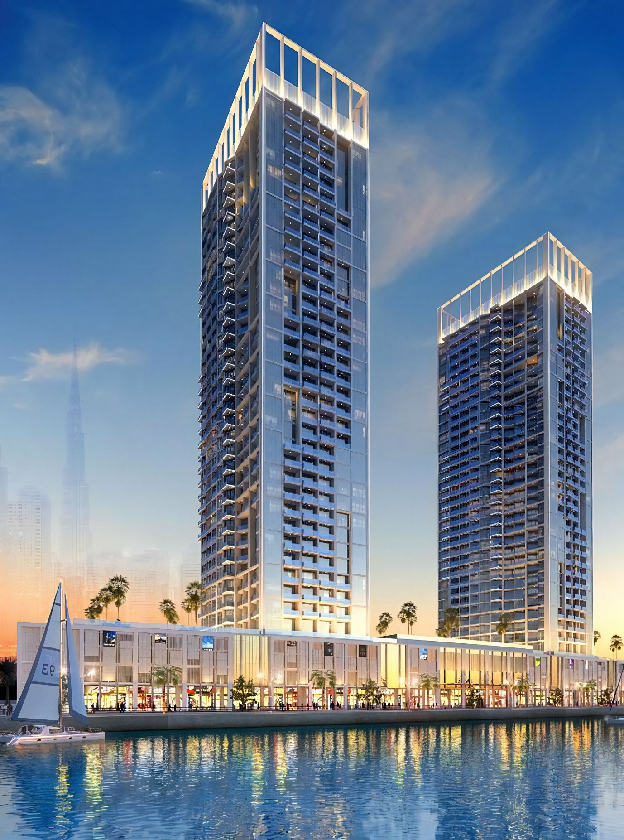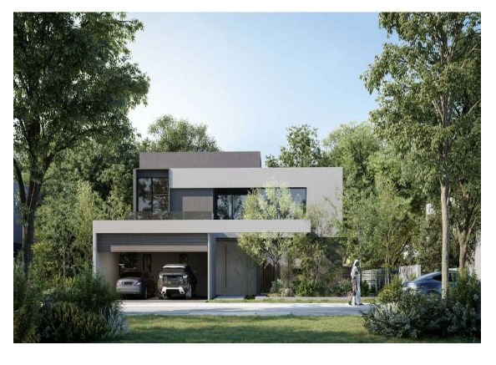

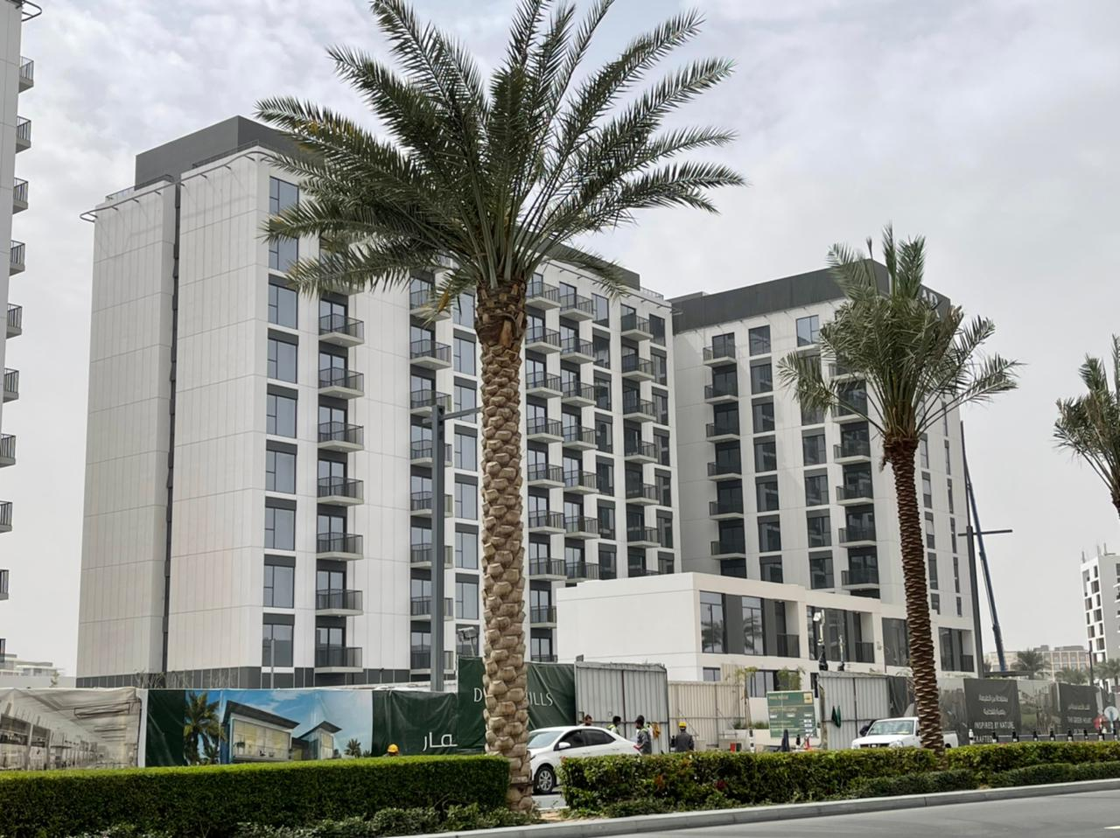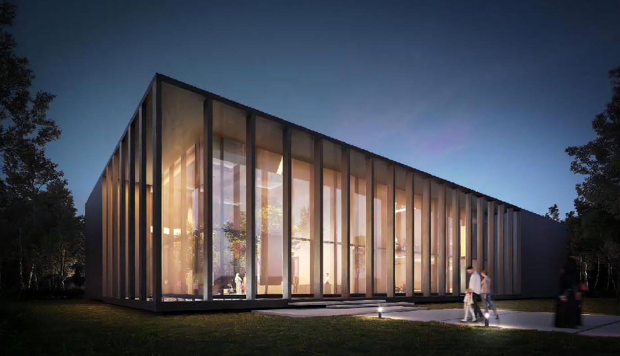

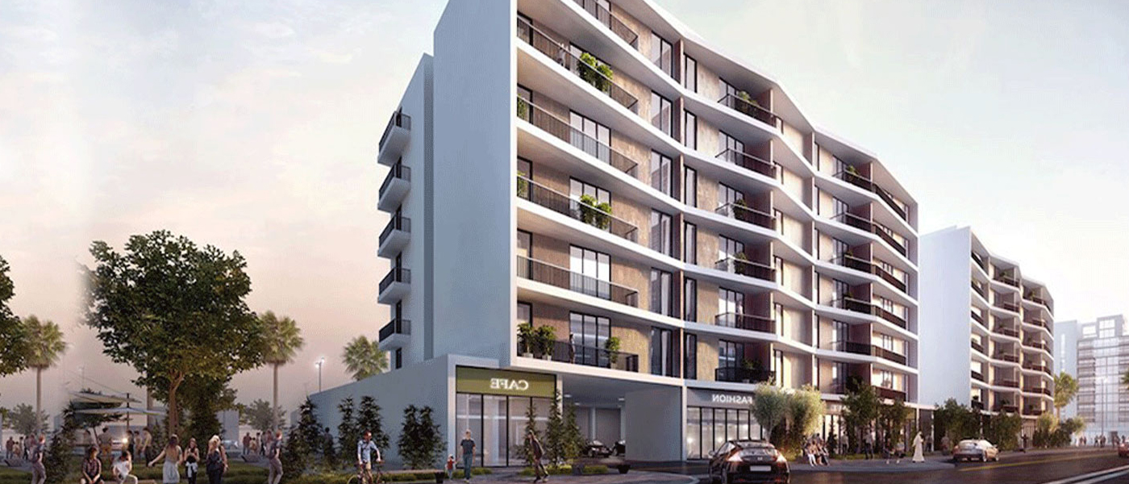

**SERVICES:**

* CONTRACTING DEPARTMENT
* TECHNICAL DEPARTMENT
* MAINTENANCE DEPARTMENT

**CONTRACTING DEPARTMENT**

**Our Special Team Of Engineers With Technicians & Skilled Manpower For Different Electromechanical Services & Systems Installations**

**� All HVAC Systems**

**� Drainage & Sanitary**

**� Plumbing Services**

**� Solar System**

**� Fire Fighting**

**� Smoke Management Systems**

**� BMS-BUILDING MANGMENT SYSTEMS**

**� LPG Systems**

**� ALL Electrical Works, Lighting & Power**

**� ELV Systems**

**For Different Projects & Premises.**

**The dedicated work execution team which includes Project Manager, discipline project engineers, site engineers, QA/QC, safety Officer, and necessary supervisors and labour forces etc. not limited, with office engineering back up will organize and execute the MEP works.**

**The authority liaison and inspections will be make sure as per the speculated authority tracking schedule. The specific commissioning program will be implemented the services associated with pre-commissioning, commissioning, and start-ups.**

**The Detailed Operation and Maintenance manuals, commissioning reports, preventive maintenance schedules & programs, material warranties, Guarantees, As built drawings, Authority approved drawings will be handed over and Client staff training will be conducted.**

**TECHNICAL DEPARTMENT**

**In Our Belief That The Effort And Engineering Planning Is The Basis For All The Projects So It Was Necessary To Prepare A Specialized Department Of Qualified Engineers With Skilled Draftsmen To Perform Engineering Works in house For All Electromechanical Services & Systems**

**� All HVAC Systems**

**� Drainage & Sanitary**

**� Plumbing Services**

**� Fire Fighting**

**� Smoke Management Systems**

**� BMS-BUILDING MANGMENT SYSTEMS**

**� LPG Systems**

**In order to begin engineering works following documents were ensured as reference documents and shop drawing and material submission will be performed as per the tracking schedules.**

**MAINTENANCE DEPARTMENT**

**A Specialized Department with qualified engineers & skilled technicians for maintenance works of different premises**

**� All Plumbing Services**

**� All HVAC Systems**

**� All Drainage &Sanitary**

**� Fire Fighting**

**� ALL Electrical Works, Lighting & Power**

**We are Offering Our clients special high quality services including preventive,corrective, predictive & overhaul maintenance with Annual contract for allabove services .**

**CAREER:**

Page having mailing option.

**ADDRESS:**

**Office Address**

**CORPORATE LINK TECHNICAL SERVICES LLC**

**26 26 16c St**

**P. O. Box 95767, Dubai, UAE**

**Phone: 04 295 2727, Fax : 04 295 2726**

**Email: Info@corporateuae.ae**